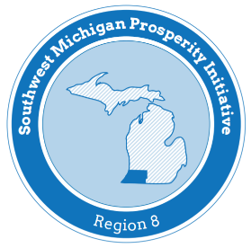

Southwest Michigan Prosperity Committee
Infrastructure Subcommittee Meeting Notes

MEETING DATE: March 18, 2019
MEETING TIME: 2:00 pm
MEETING LOCATION:

W.E. Upjohn Institute
300 South Westnedge Ave
Kalamazoo, MI 49008

SWMPC
376 W. Main Street Suite 130
Benton Harbor, MI 49022

Virtual Attendance Credentials:
https://www.gotomeet.me/Upjohn
You can also dial in using your phone.
United States (Toll Free): 1 877 309 2073
United States: +1 (669) 224-3217

Access Code: 422-647-013

Agenda

- Review Current Status of Statewide Asset Management Progress

- Developments toward Regional Summit Meetings

- Other Opportunities

- Miscellaneous

Next Meeting: April 15, 2019

